Tutor: Penelope Rose Cowley
Website: www.peneloperosecowley.com Email: info@peneloperosecowley.com
Images: Pre-order colour pictures references £0.50 each. Fill in order sheet in sessions or email tutor. You can also download from website:
http://www.peneloperosecowley.com/reference-materials.html
All images are provided by ether the tutor or available from Pixabay. Pixabay is a royalty free image bank for commercial and creative uses.
https://pixabay.com
You may decide to use your own similar picture references for each session. It is recommended that you use something like Pixabay to ensure royalty free status or your own images.
Other options are available for more independent study from tutor's selection of reference materials. These can be downloaded from the website or requested as and when required.

Autumn Term 2017 Watercolour

Session 1: Drawing and Painting techniques.
Basic 'M' shaped mountains with lake and textured foreground scene. Making use of the cling film technique.

Session 2: Sunset 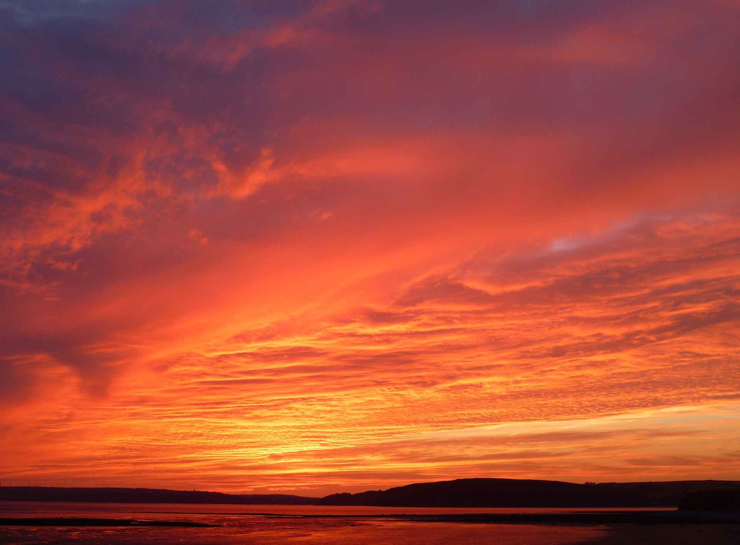

Session 3: Giraffe
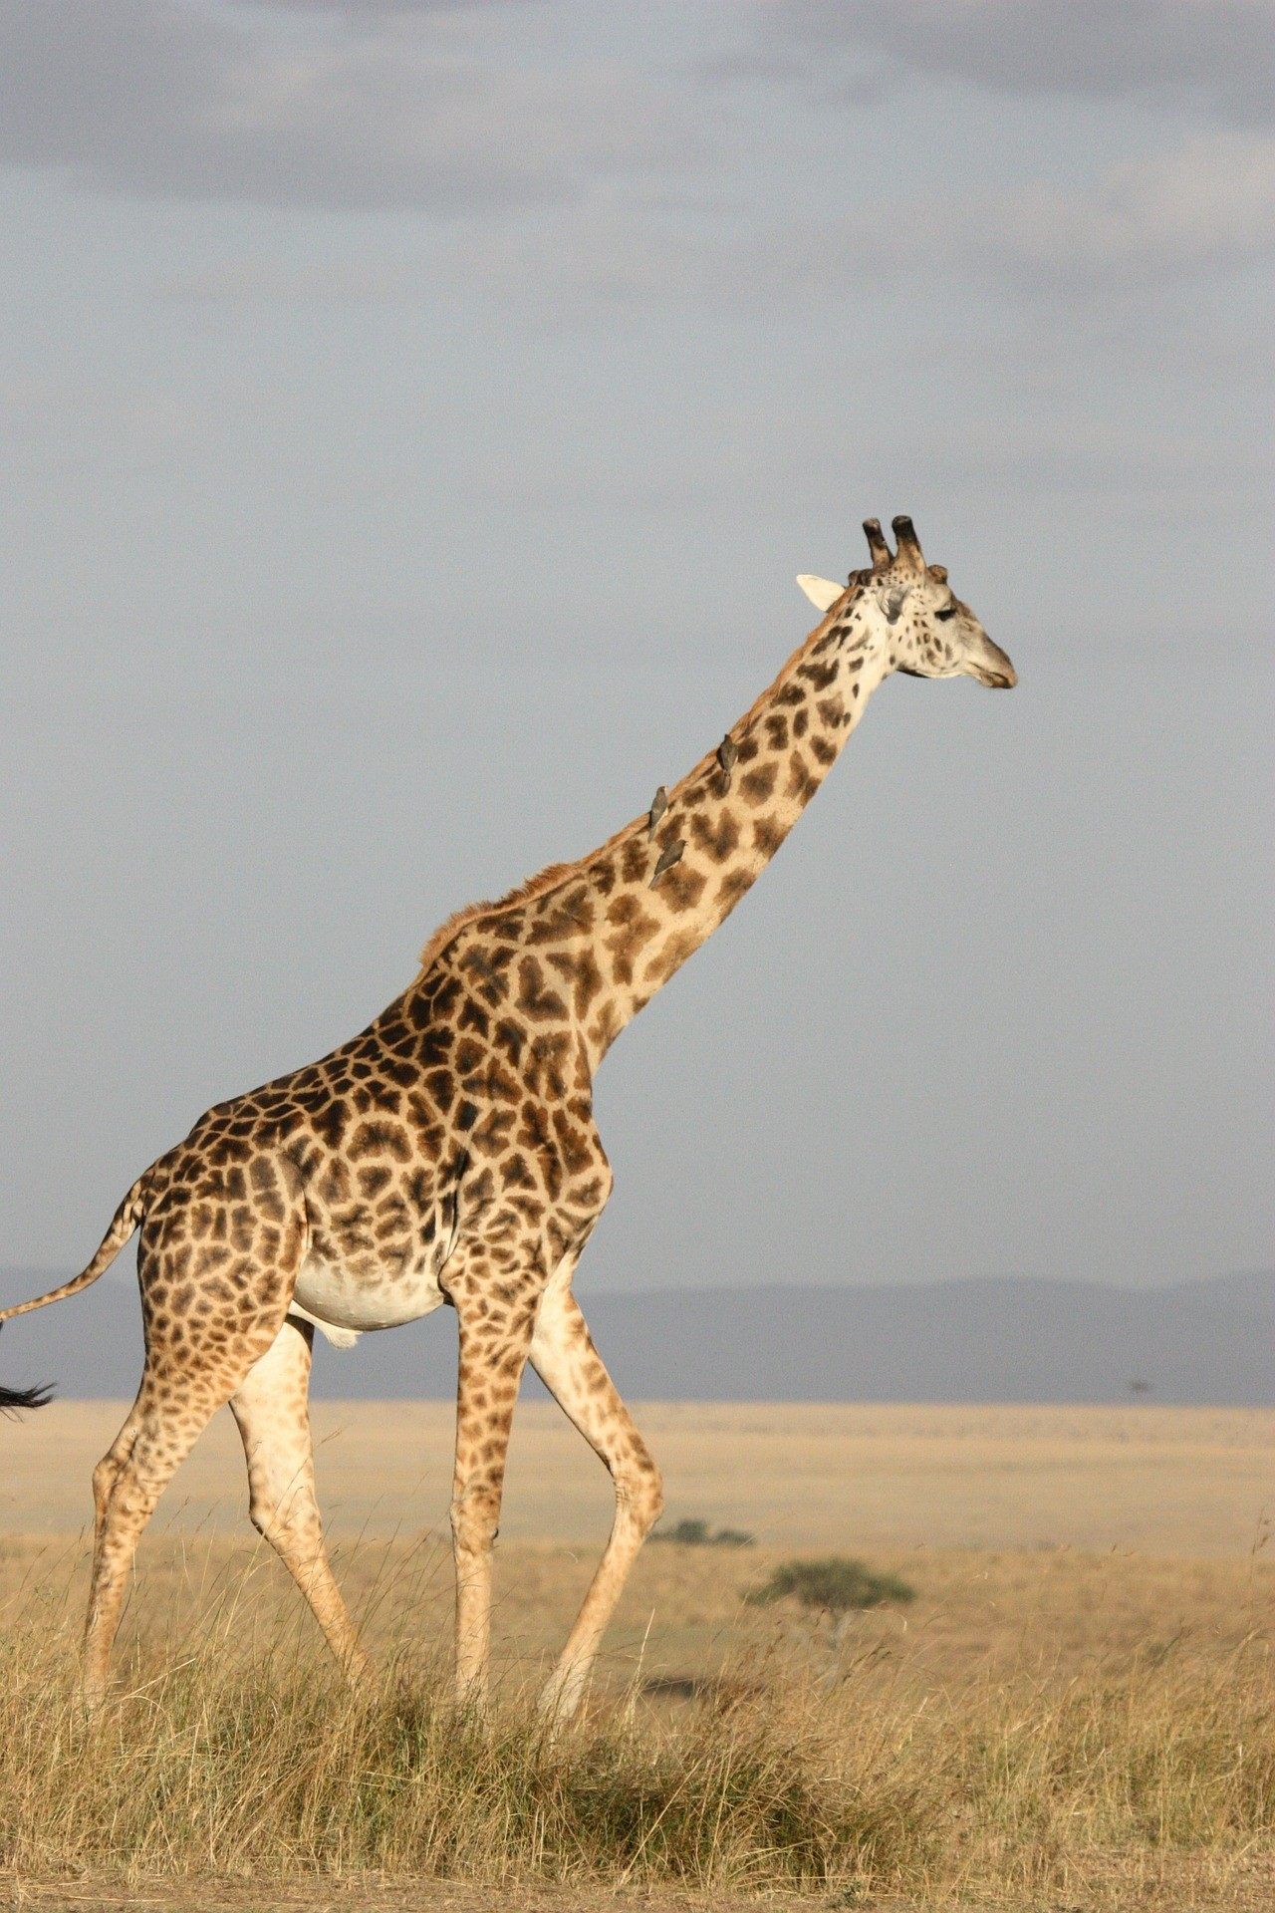

Session 5: Flowers Forget-me-nots
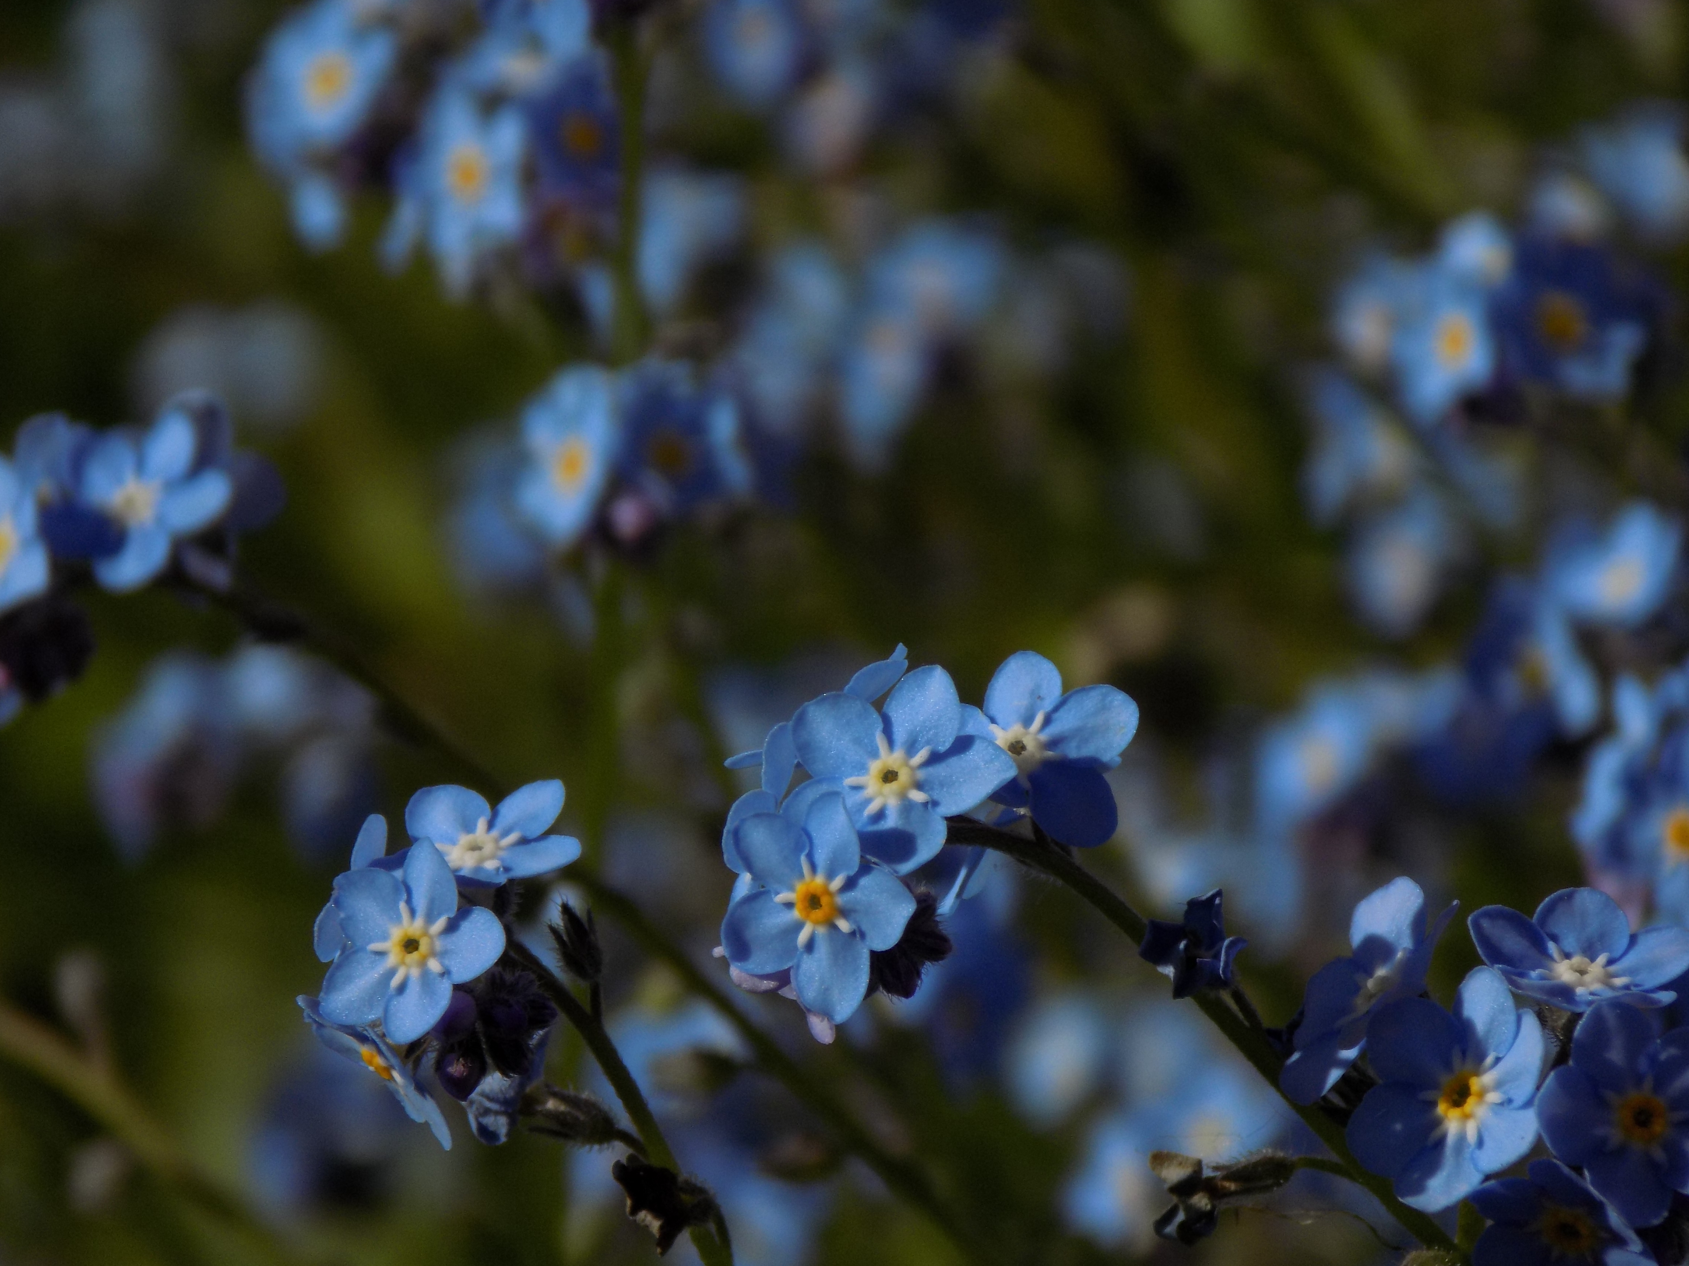

Session 6: Elephants
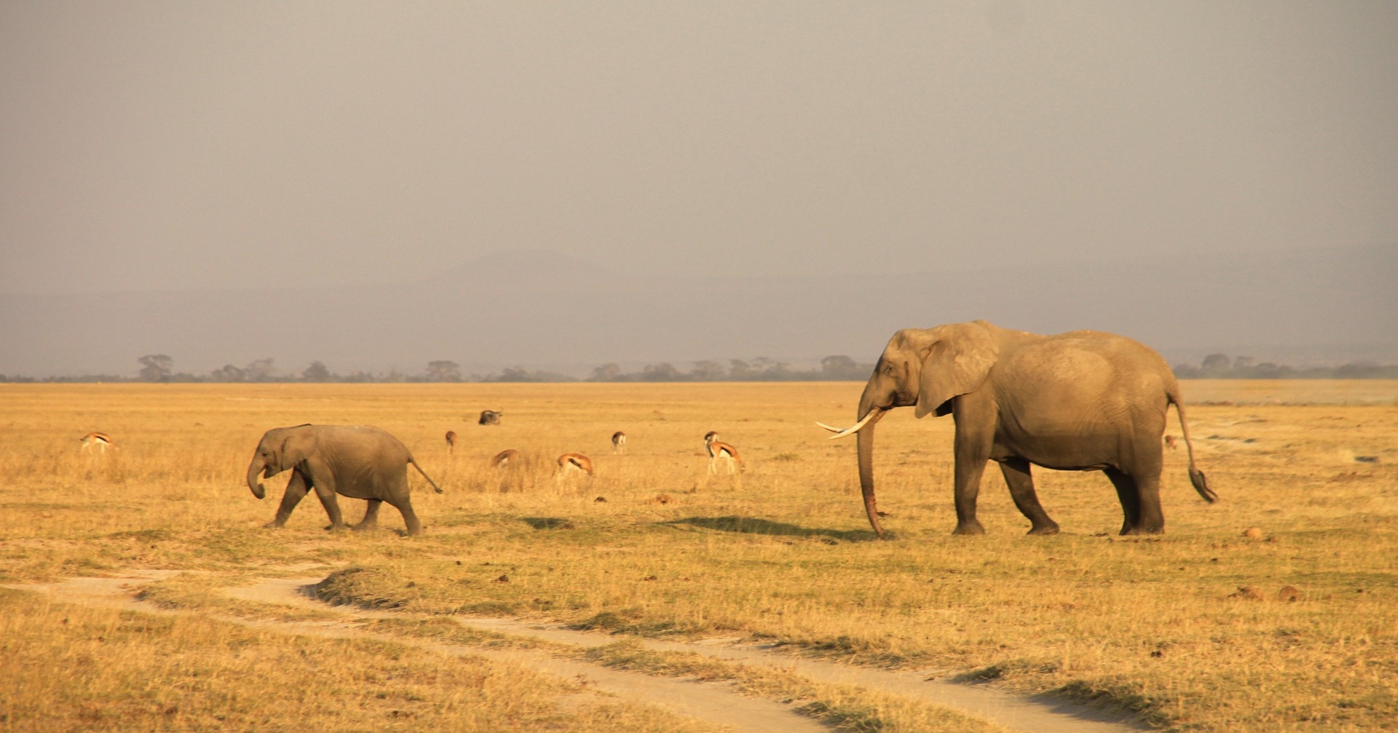

Session 7: Windmill
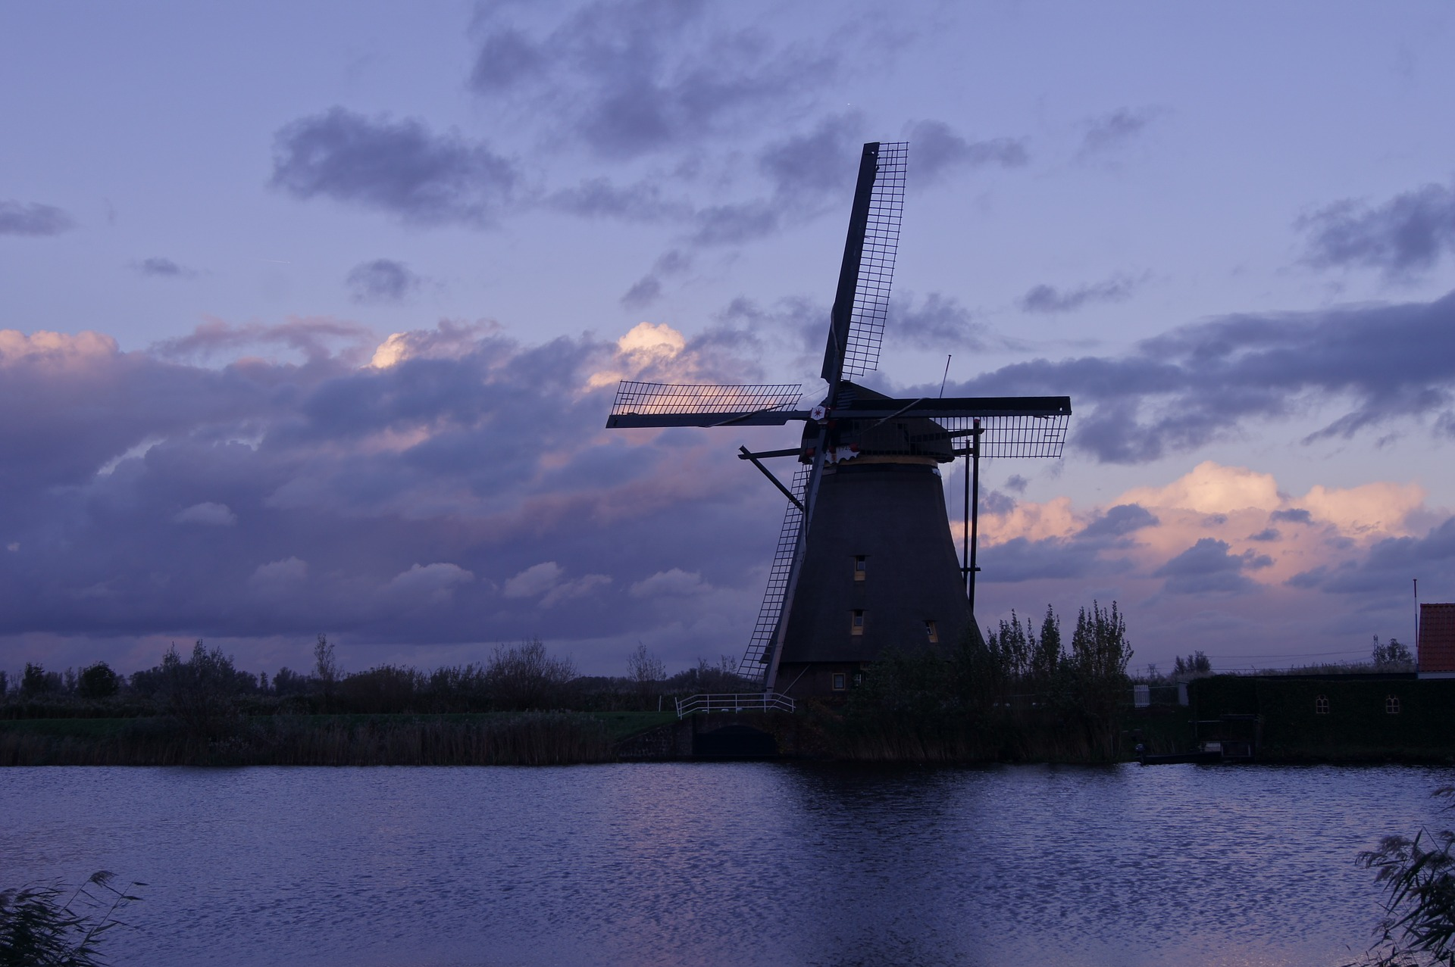

Session 8: Still Life
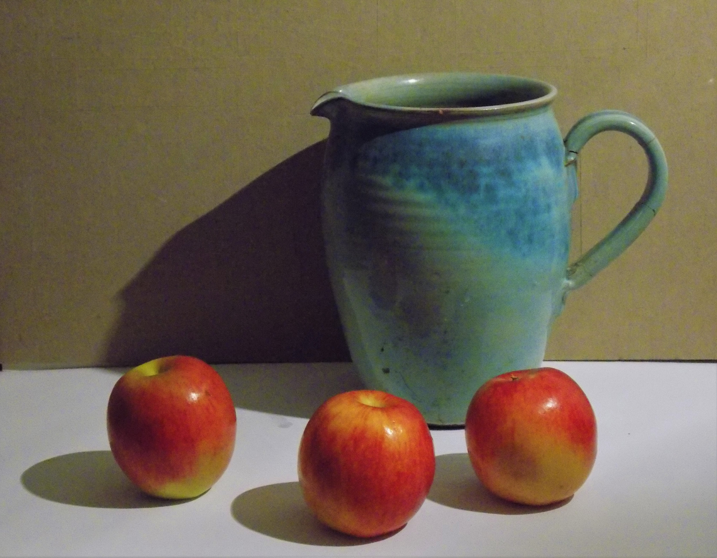

Session 9: Waterfall
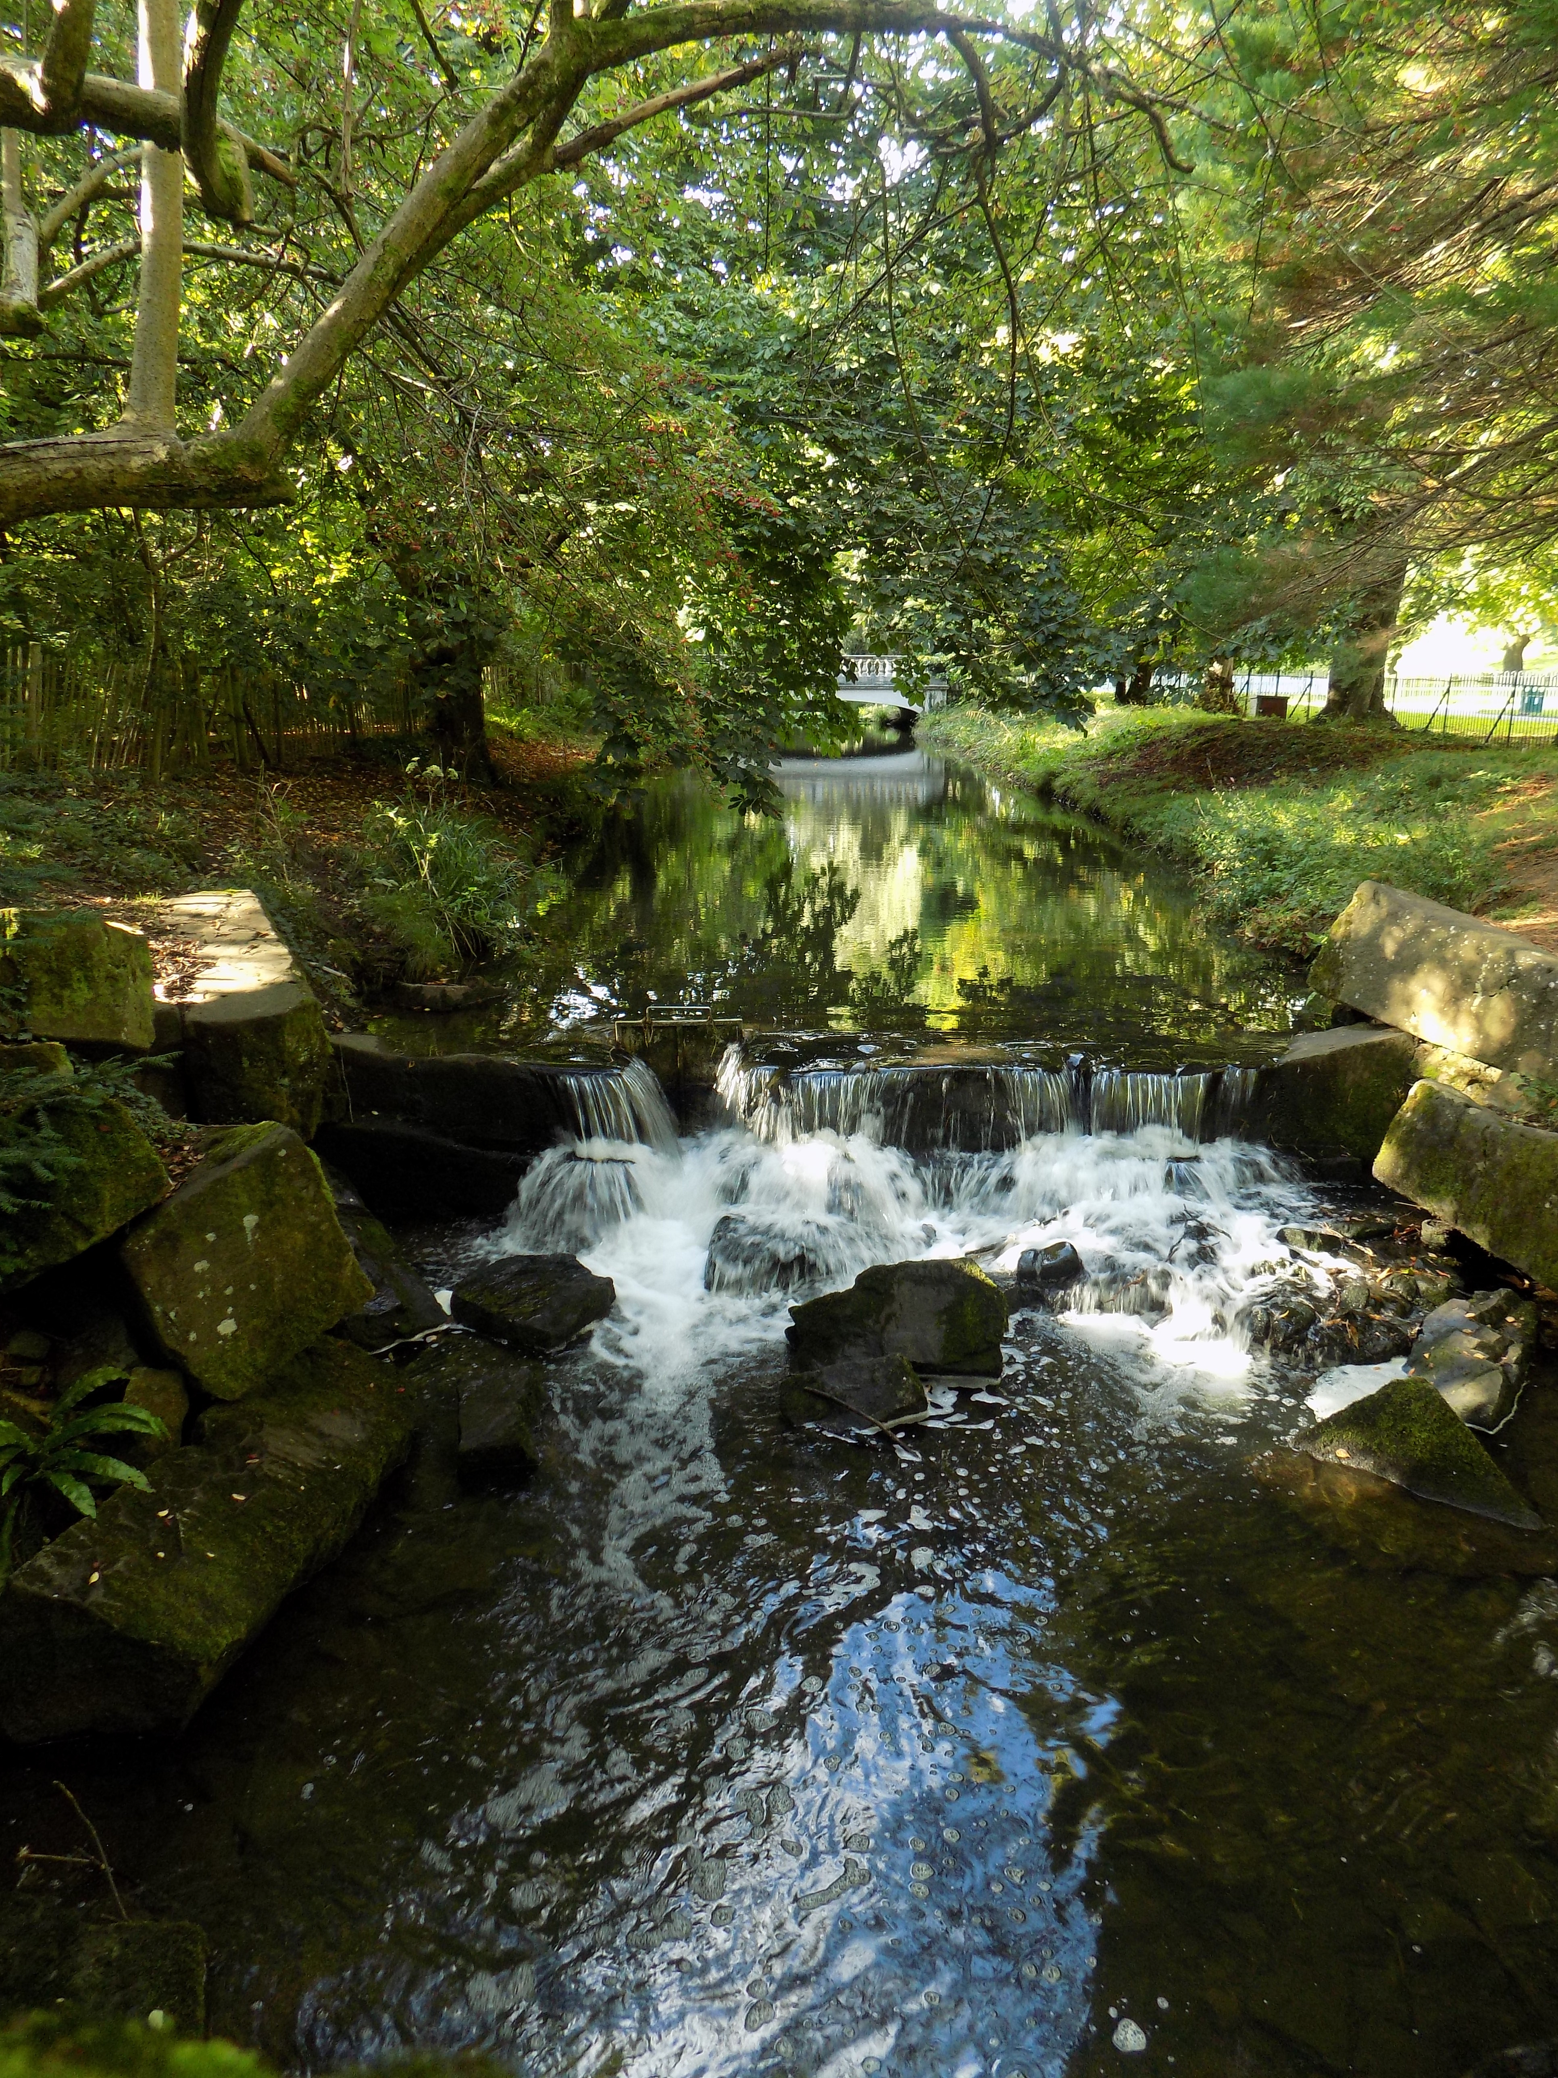

Session 10: Free Choice

